Smart Contract Management Engine

Requirement Analysis
Functional Requirements:
- Contract Ingestion
- Contract Indexing
- Contract Benchmarking and Validation against similar contracts
- AI Contract Generation Engine
- Clause Recommendation and Deviation Engine
- Clause Identification and Risk Identification
- Global Compliance Validation
- Clause Repository
Non-Functional Requirements
- Scalable
- Secure
- Performant
- Compliance

System Architecture Diagram
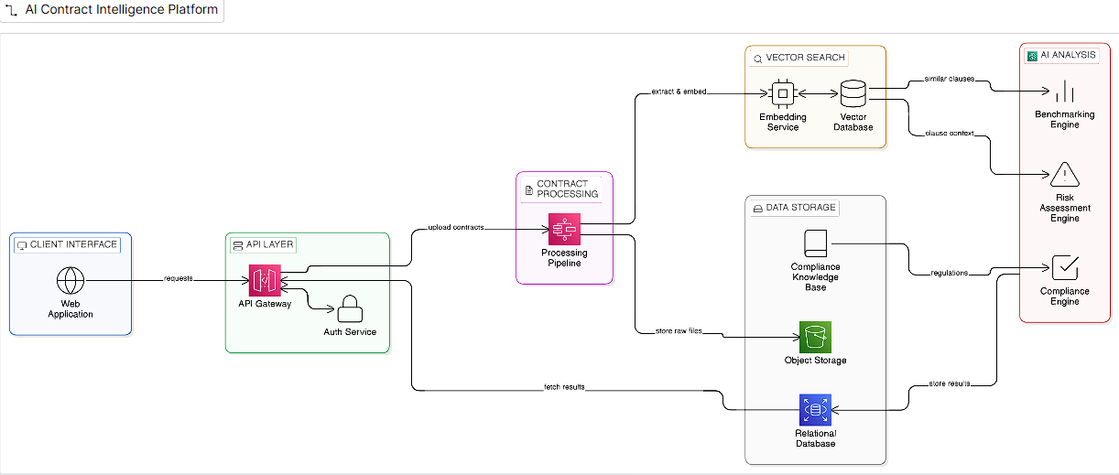
USE CASES:
- Contract Validation
- Faster Decision Cycles
- Compliance Checks
- Risk Management
- Mergers and Acquisitions
- Procurement

